.........empty row..........
TITLE: TIMES NEW ROMAN (12 points, bold, capital), centered, spacing 1
.........empty row..........
Name and surname of authors: (Font: Times New Roman, 12 pts., normal), centered, spacing 1
.........empty row..........
Address(es):(Font: Times new roman (12 pts., italic), start from the left margin, spacing 1), e-mail
.........empty row..........
.........empty row..........
Abstract (language of abstract: English !!!) (Text of the abstract: Font: Times New Roman (12 pts., normal), spacing 1) Abstract shall be written in English and should be informative (summarising objective, methods and main results) and should not exceed 150 words.
Text Text Text Text Text Text Text Text Text Text Text Text Text Text Text Text Text Text Text Text Text Text Text Text Text Text Text Text Text Text Text Text Text Text Text Text Text Text Text Text Text Text Text Text Text Text Text Text Text Text Text Text Text Text Text Text Text Text Text Text Text Text Text Text Text Text Text Text Text Text Text Text Text Text Text Text Text Text Text Text Text Text Text Text Text Text Text Text Text Text Text Text Text Text Text Text Text
.........empty row..........
Key words: Font: Times New Roman (12 pts., normal), spacing 1
.........empty row..........
Introduction (Text of the article: Font: Times new roman (12 pts. normal), spacing 1)
Structure of the article according the common rules for the scientific papers. Keep headings and subheadings always flushed left. Put one blank line over a heading.
Text Text Text Text Text Text Text Text Text Text Text Text Text Text Text Text Text Text Text Text Text Text Text Text Text Text Text Text Text Text Text Text Text Text Text Text Text Text Text Text Text Text Text Text Text Text Text Text Text Text Text Text Text Text Text Text Text Text Text Text Text Text Text Text Text Text Text Text Text Text Text Text Text Text Text Text Text Text Text Text Text Text Text
.........empty row..........
Experimental (Text of the Experimental: Font: Times New Roman (12 pts., normal), spacing 1)
Text Text Text Text Text Text Text Text Text Text Text Text Text Text Text Text Text Text Text Text Text Text Text Text Text Text Text Text Text Text Text Text Text Text Text Text Text Text Text Text Text Text Text Text Text Text Text Text Text Text Text Text Text Text Text Text Text Text Text Text Text Text Text Text Text Text Text Text Text Text Text Text Text Text Text Text Text Text Text Text Text Text Text
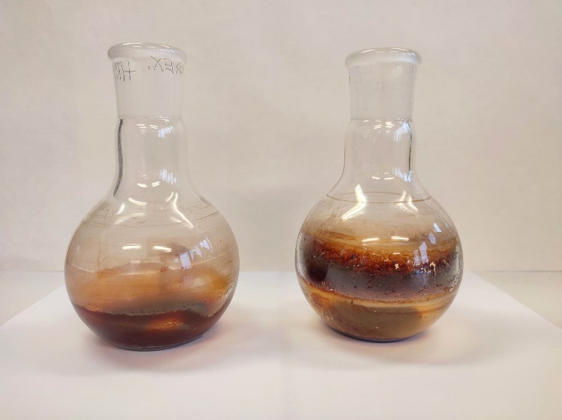
Fig. 1: Text

Text Text Text Text Text Text Text Text Text Text Text Text Text Text Text Text Text Text Text Text Text Text Text Text Text Text Text Text Text Text Text Text Text Text Text Text Text Text Text Text Text Text Text Text Text Text Text Text Text Text Text Text Text Text Text Text Text Text Text Text Text Text Text Text Text Text Text Text Text Text Text Text Text Text Text Text Text (Adámková et al. 2002).

Tab.1 Text

Text Text Text Text Text Text Text Text Text Text Text Text Text Text Text Text Text Text Text Text Text Text Text Text Text Text Text Text Text Text Text Text Text Text Text Text Text Text Text Text Text Text Text Text Text Text Text Text Text Text Text Text Text Text Text Text Text Text Text Text Text Text Text Text Text Text Text Text Text Text Text Text Text Text Text Text (Osvald 1997)
.........empty row..........
Acknowledgement: Times New Roman (11 pts., italic), start from the left margin, spacing 1
.........empty row..........
References:
Times New Roman (12 pts., normal), start from the left margin, spacing 1 (in alphabetical order)
for example:
Adámková, G., Milichovský, M., Nesládek, I. 2002. Hygroskopicita papíru a papírenských výrobků. Papír a celulóza, 57(4): 105-107.
Osvald, A. 1997. Požiarnotechnické vlastnosti dreva a materiálov na báze dreva: Vedecké štúdie 8/1997/A. Zvolen: Technická univerzita vo Zvolene, 1997. 52 s.
Zailani, S., Govindan, K., Iranmanesh, M., Shaharudin, M.R., Chong, S. 2015. Green innovation adoption in automotive supply chain: the Malaysian case. Journal of Cleaner Production. 2015, 108: 1115–1122. DOI:10.1016/j.jclepro.2015.06.039

Send contributions in the specified format and scope electronically by 7 May 2024 to the following addresses:
PhD. Students Section: cabalova@tuzvo.sk
Technological- Technical Section: slabejova@tuzvo.sk
Section of Economics, Management and Business: simanova@tuzvo.sk
Marketing, Trade and Innovative Management Section: kaputa@tuzvo.sk (olsiakova@tuzvo.sk)
Section of Safety and Security Sciences: zachar@tuzvo.sk
Art-Design Section: katarina.boborova@gmail.com
High School Section: jozef.fekiac@tuzvo.sk
Extent of the paper shall be adequate to its scientific contribution and shall not exceed 15 pages written in text editor, including tables and figures. Figures and tables shall be compact and reasonable, while the same data shall not be duplicated in both forms.
Paper shall be written in English language. Authors are responsible for language standards.

